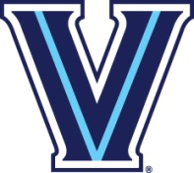
Appendix X

Villanova Club Sports

Branding, Logos, and Marketing

University Verbiage
- Villanova University
- Villanova
- Wildcats
- Nova
- Villanova Wildcats
- Nova Nation
- IGNITE CHANGE. GO NOVA

General University Information
- Location: Villanova, PA
- Mascot: Wildcats
- Mascot Name: Will D. Cat
- Established Date: 1842

Garment Colors
- The University’s primary colors are Navy and White. All apparel (including: uniforms, jerseys, staff wear, practice uniforms, warm-up gear, travel apparel, etc.) must be Navy or White. Exception: Practice T-Shirts and Practice Sweats may be Athletic Grey (also known as Athletic Heather and Sports Grey).
- The primary “V” logo may be performed using one color. The approved format is show in the Villanova University Athletic Marks section.
- Embroidery of any logo should be performed using the exact color specifications shown in the Villanova University Color Usage section.
- A specific sport name may appear under a primary mark but it must appear in white or navy in Garamond Bold.

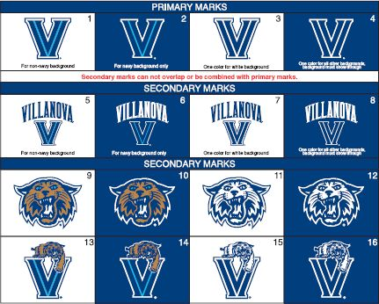
Villanova University Athletic Marks

Villanova University Color Usage
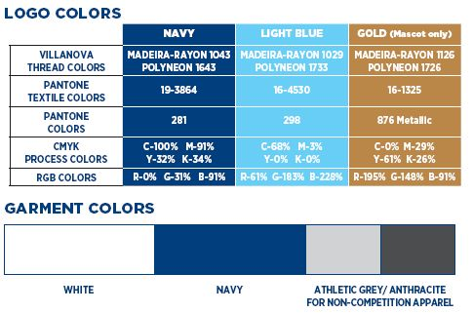

Social Media Marketing
- Two Way Exchange: Should be accessible to students following the account
- Short Posts: Look for current campus themes and use relatable content (hashtags, expressions, etc.)
- Consistent Voice: Have one or two individuals be the point of contact for social media so they can have a consistent voice while being fun and clever, yet informative
- Timing: Continuity is key in order to increase likes, shares, and views.
  - Facebook timing – 1pm and 3pm
  - Twitter timing – 12pm, 5pm, and 6pm
  - Think of the flow of classroom changes as well as mealtime breaks

