Introduction
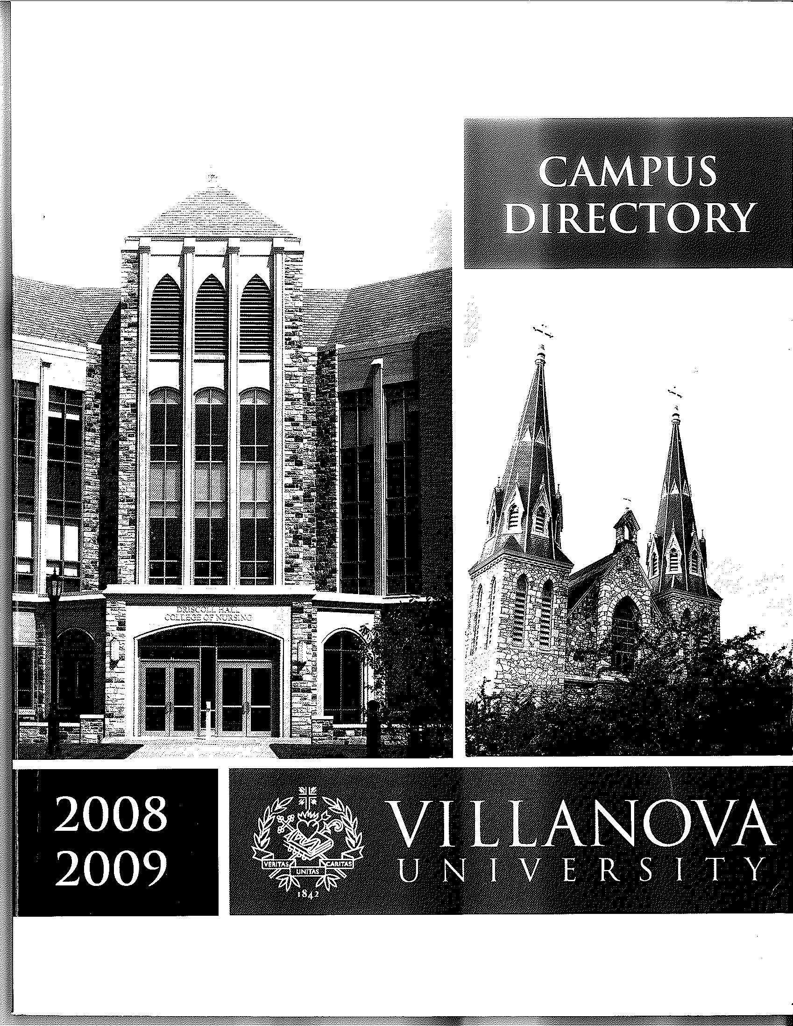
The Villanova Campus Directory has been retired in our efforts to go green and also to take advantage of the many different electronic, online options. This document gives you resources you can use to find information about Villanova Faculty, Staff and Students.

Resources

VU Online Campus Directory - URL
You can use http://www.villanova.edu/directoryservices/control in your browser to get to the Campus Directory.
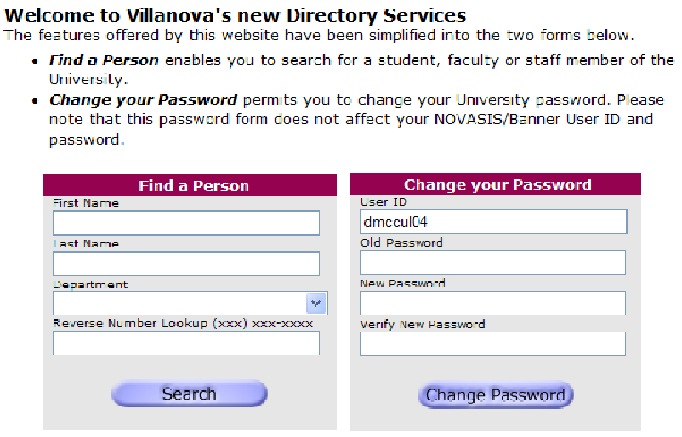

myNOVA
The Home Page of myNOVA has a link at the bottom of the first column to access the online Campus Directory. You can search by first name, last name, department or reverse phone number lookup.
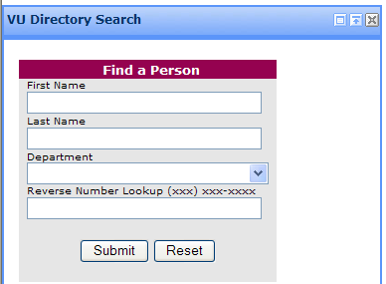

Dial by Voice Telephone Options
You can dial our automated speech attendant system at 95500. You are prompted: “Which person or service would you like to reach.” Say the first and last name. A match between the pronunciation and the written name in the system is attempted, and you will be connected to the person. Therefore, it is important that you rerecord your voice in that system to increase the odds of getting a correct audio pronunciation match.
- Connect to the Auto Attendant (x95500).
- On the "person or service" prompt, press 123.
- Press 1 to locate your name in the speech directory.
- Say your first name and last name
- Press 1 to confirm
- For the prompt to enter your PIN #, enter your Banner ID /Novasis (8-character number); which can be found when you first log into the Banner system.
- Press 1 when ready to record your first and last name, and to confirm after saying your name.
See the UNIT website for more information: http://www.villanova.edu/unit/support/telecom/features/dialbyvoice.htm

Copy Machine Options
You can see the names of people in your department on your copy machine, which also lists their email address.

Outlook Address Book –Properties Option
You can open Outlook’s Address book and look up a person.
- Type in the person’s name in the Address Book
- Press the Enter key or right-click the person’s name
- Select Properties,
Contact information appears in several tabs for the person you searched.
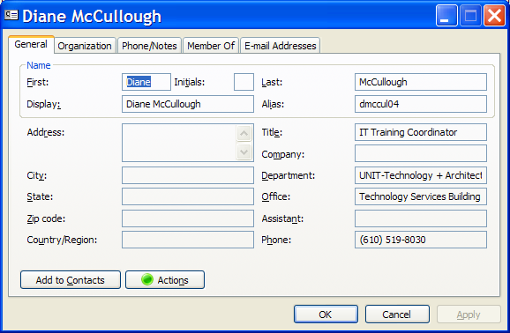

Outlook Email Properties Option
- New Email Message Screen:
- Type in the person’s first name
- Press Ctrl+K to display a list of all the people with that first name.
- Closed Email Message in Your Inbox:
- Open the email.
- Right click the email name of the person.**
- Click Outlook properties to display their contact information in several tabs.
- Click the “Email Address” tab to display the email address (after the SMTP: command.)
Note: Click the “Add to Contacts” button to add the person to your personal contact list.

**TIP: Right clicking the sender’s name also has an option to add the sender your Outlook Contacts list.

