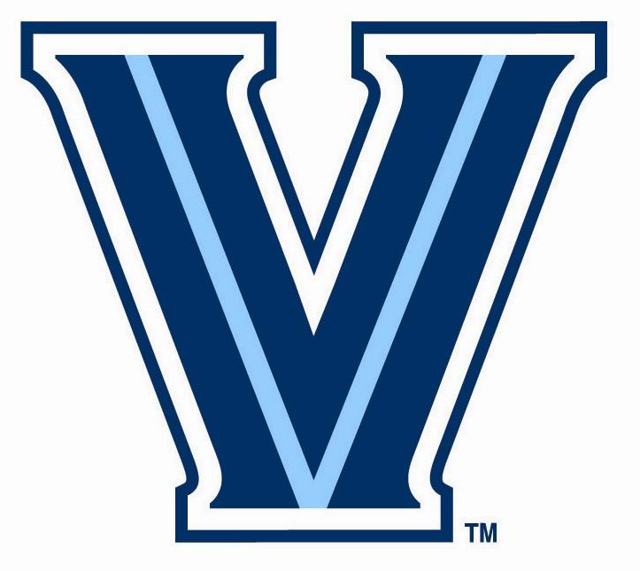

Villanova University Intramurals

Returning Employee Availability – Fall 2022

Name: _______________ Banner ID#: _________

Primary Phone #:______________ Email Address: _____________________

Year: Fr____ So_ __ Jr ____ Sr ____ Grad____

Official & Scorekeeper ______ Supervisor _______

♦ Availability: Please check only the times and sports you are qualified and available to work:

FLAG FOOTBALL (Friday, September 9th – Monday, November 14th)
Check position(s) for which you are applying: ____ Scorekeeper only ____ Referee & Scorekeeper

Mondays: | Tuesdays: | Wednesdays: | Thursdays: | Fridays:
2:30pm-7:00pm | 2:30pm-7:00pm | 2:30pm-7:00pm | 2:30pm-7:00pm | 2:30pm-7:00pm

Sunday Shift #1 | Sunday Shift #2 | Sunday Shift #3
9:00am-12:15pm | 12:00pm-3:15pm | 3:00pm-6:15pm

OUTDOOR SOCCER (Thursday, September 6th – Monday, November 21st)
Check position(s) for which you are applying: _____ Scorekeeper only ____ Referee & Scorekeeper

Mondays: | Tuesdays: | Wednesdays: | Thursdays:
6:00pm-10:00pm | 6:00pm-10:00pm | 6:00pm-10:00pm | 6:00pm-10:00pm

Sunday Shift #1 | Sunday Shift #2 | Sunday Shift #3
9:00am-12:15pm | 12:00pm-3:15pm | 3:00pm-6:15pm

If you have any questions please contact Tanner Noble, Intramural Sports Intern at tanner.noble@villanova.edu

