VILLANOVA INTRAMURAL SPORTS
Futsal RULES
Updated: 2/2023
GAME TIME IS FORFEIT TIME!
All decisions on forfeit times are at the sole discretion of the on-site Intramural supervisor.

Eligibility
- Current Villanova men’s and women’s soccer players are ineligible to play in the same academic year.
- No more than two (2) club players per intramural team.

Teams
- Play will be 5-on-5 (four field players and a goalkeeper)
- A team must have four players to begin play, anything less is a forfeit.

The Game/Timing
- There is no offsides in Futsal
- Kickoff is indirect and must start with a participant to participant pass.
- Two (2) seventeen-minute halves.
- Possession will be determined by a coin toss at the captain’s meeting.
- The clock will be a running clock and will only be stopped for an injury. Clock will stop in the last minute of the game for dead ball situations and goals.
- NO TIMEOUTS in Futsal. (only for injuries)
- Halftime will not exceed three (3) minutes.

Mercy Rule
- If a team is winning by ten (10) or more goals at any time in the second half then the game will automatically end.
- If a team is winning by seven (7) or more goals with 5 minutes left in the second half then the game will automatically end.
- If a team is winning by five (5) or more goals with 2 minutes left in the second half then the game will automatically end.

Substitutions
- All substitutes must check in at the scores table.
- Substitutions are allowed on stoppage of play (Goals or any Deadball Scenario).
- Substitutes must stay against the wall (or behind the barrier) and may not interfere with play.

Goal/Goalkeeper/Goal Box
- Goal Clearances: The ball is thrown in by the goalie anywhere inside the penalty area and is presumed live once it leaves his hands. Opponents must be outside the penalty area during a goal clearance.
- The goalkeeper shall not punt or drop kick, but may either throw or roll the ball to release their possession of it. If thrown in the air, the ball must come in contact with an object (floor, wall or body) before going over half court. If the ball does not come in contact with an object then the other team receives a direct kick at half court.
- The goalie is not allowed to play the ball with his or her hands if it is played back to him/her by a teammate!
- Goalies may leave the penalty box, but once outside cannot use their hands in any way.
  - Results in a handball and possession to the other team.
- Goalies can slide to save a ball as long as they are not sliding toward any players.
- Once in possession of the ball, goalies have six (6) seconds to put the ball into play.
  - A free kick is awarded to the opposing team at the nearest point at the edge of the penalty area if the play is not played within six (6) seconds.
- Goal boxes will be designated.

Boundaries
- If any ball leaves the field of play, or hits the roof, the rafters, the ceiling, any part of the basket, and/or the lights it will result in a dead ball and the opposing team will get a kick-in where the ball went out of bounds.
  - Kick-ins are indirect and must be taken within six (6) seconds of the ball being placed on the line. Kick-ins take the place of throw-ins.
- If the ball is deflected by the keeper and deflects into any part of the basket above their goal, the ball will be played as a corner.
  - Corner kicks are direct and must be taken within six (6) seconds of the ball being placed on the corner.
- If a ball gets stuck anywhere, play will resume with a drop ball.

Fouls/Penalties/Penalty Kicks
- All kicks are DIRECT. All opponents must be at least 5 yards from the ball before play resumes.
  - Direct kick - a goal may be scored against the offending team
  - Note: officials do not have to blow whistle for direct kicks to be taken; play can continue. Officials will only stop play to count out five yards from the ball if asked and then will use a whistle to allow kick/continue play.
- There will be no sliding or checking, these will result in yellow or red cards, depending on the severity of the action.
- Slide tackles are illegal! Will result in a yellow or red card and a direct kick for the opposing team.
- Penalty kicks will be taken from a mark designated on the court by tape. If there is no mark, the referee will measure twelve steps from the goal line and mark the spot of the penalty.
- The goalie must remain on the goal line until the kick is taken. Lateral movement is acceptable but movement forward or backwards before the kick is taken will result in a re-kick if the attempt is not successful.

Cautionable Offenses (yellow cards)
A player is cautioned and shown the yellow card if he/she commits any of the following seven offenses:
- Unsporting behavior
- Dissent by word or action
- Persistent infringement of the Laws of the Game
- Delaying the restart of play
- Failure to respect the required distance when play is restarted with a direct kick (5 yards)
  - Each team will receive a team warning the first time yards are blatantly ignored (Within 2 yards prior to warning), after that the offending player will receive a yellow card for each additional violation.
- Entering or re-entering the field of play without without the referee’s permission
- Deliberately leaving the field of play without the referee’s permission
- Sliding tackling (non-aggressive)
- Checking or bodying a player. (non-aggressive)
- Interference with Goalkeeper

A substitute or substituted player is cautioned if he commits any of the following three offenses:
- Unsporting behavior
- Dissent by word or action
- Delaying the restart of play
- Persistent interference with play

Sending-off Offenses (red cards)
A player, substitute or substituted player is sent off if he/she commits any of the following seven offenses:
The team will have to play down a person for the remainder of the game.
- Serious foul play
- Violent conduct
- Denying the opposing team a goal or an obvious goal-scoring opportunity by deliberately handling the ball (this does not apply to a goalkeeper within his own penalty area)
- Denying an obvious goal-scoring opportunity to an opponent moving towards the player’s goal by an offense punishable by a free kick or a penalty kick
- Using offensive, insulting or abusive language and/or gesture
- Receiving a second caution (yellow card) in the same match
- Flagrant Slide tackle or checking

A player, substitute or substituted player who has been sent off must leave the vicinity of the field. If any player is sent off during the course of a match, that team will receive a sportsmanship rating of 2 or lower automatically.

Overtime Rules
- There is no overtime in the regular season. All games will end in a tie.
- During the playoffs, there will be a 5 minute, sudden death, overtime period. Possession will be determined by another coin toss at the beginning of the period.
- If play is still tied by the end of the 5 minute period, the match will go to a best of 5 penalty shootout. Only players who are on the field at the end of the overtime period are eligible to partake in the shootout. A coin toss is used to determine which team will kick first.
- If the shootout is tied after a best of 5 round, then the shootout will move to a sudden death round.

Other
- Please remain outside the gym until the previous game is finished.

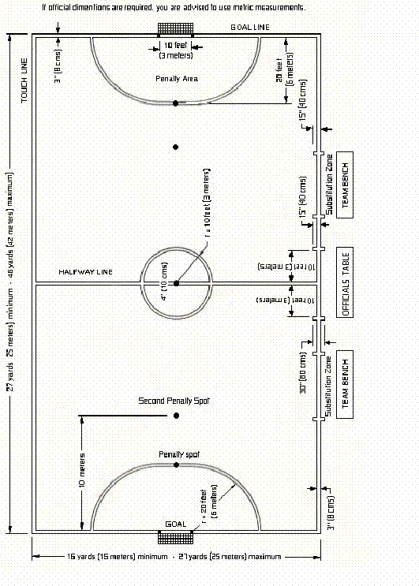
Court

