THE UNIVERSITY COMPLIANCE OFFICE
oversees the compliance and ethics program, which supports Villanova’s mission and its community of faculty, staff and students in the pursuit of their academic, administrative, athletic, engagement and research activities.
All members of the Villanova community should strive to create an environment that promotes the highest ethical standards in all that we do.

WHAT WE DO

The Compliance Office serves to:
- Assist with any compliance-related questions or concerns;
- Promote compliance with applicable laws and the highest ethical standards in the pursuit of all University activities;
- Raise awareness of high-risk compliance areas, and the University policies and processes in place to support these areas;
- Identify and assess risks, and select appropriate management strategies to lessen their possible impact;
- Coordinate compliance-related functions and offices throughout campus; and
- Assure internal and external stakeholders of Villanova’s diligence in keeping compliance and ethics considerations at the core of how we conduct ourselves as stewards of the University and its resources.

ETHICSPOINT HOTLINE
This hotline is a confidential online- and phone- based service that gives faculty, staff and students an anonymous and confidential way to report misconduct in the workplace or classroom, or other violations of law or University policy.

Call toll-free 24 hours a day 365 days a year 855.236.1443
www.ethicspoint.com
Remember that this service is NOT to be used in case of emergencies. For emergencies, DIAL
- ext. 9-4444 (on campus)
- 610.519.4444 (off-campus) or
- 911

TITLE IX
Title IX protects all individuals from discrimination based on sex in education programs or activities that receive federal financial assistance from the U.S. Department of Education.
The Title IX Coordinator:
- Provides oversight to the University’s compliance with regard to Title IX requirements;
- Works with the University community on sexual violence prevention and intervention education; and facilitates access to appropriate resources and support should an incident occur; and
- Assists individuals involved in reports to resolve the matter in a prompt and equitable manner.

MINORS/YOUTH PROGRAMS
There are extensive legislative and regulatory requirements to comply with when hosting youth and/or minors programs on campus.
Villanova University faculty, staff and students are strongly encouraged to ask questions and raise concerns.
Anyone expressing such a concern or report is protected from retaliation.
If you host a minors/youth program at or through Villanova, whether as a faculty member providing an academic enrichment program to a group of minors in your classroom or lab, or as an athletic coach running a youth program, the Compliance Office website details a number of policies and resources to be aware of:
- Child Abuse Reporting Obligations
- Program Assessments
- Online Program Registration
- Criminal Background Checks
- Education & Training Requirements
- Policies and Procedures

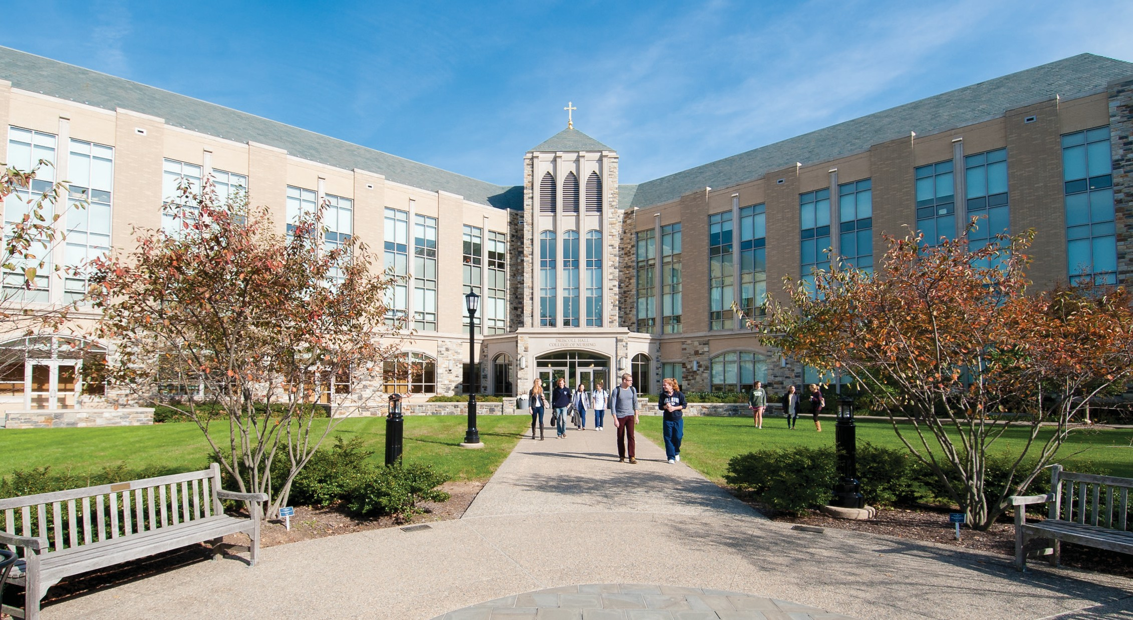

WHO WE ARE
Leyda L. Benitez
University Compliance Officer leyda.benitez@villanova.edu 610.519.3976
James Allsman
Assistant University Compliance Officer james.allsman@villanova.edu 610.519.3967
Beth Wright
Senior Compliance Analyst elizabeth.j.wright@villanova.edu 610.519.8853
Ryan Rost
Title IX Coordinator ryan.rost@villanova.edu 610.519.8805
Donna Poupard
Executive Administrative Assistant donna.poupard@villanova.edu 610.519.5466

WHEN SHOULD I CONTACT THE UNIVERSITY COMPLIANCE OFFICE?
- Does it just feel like the right thing to do?
- Does it impact academic or research integrity?
- Does it involve the misuse of state or federal resources or funds?
- Do you have a safety concern about the nature of the activity or the available resources to do the job?
- Does it compromise respect for the dignity of the individual?
- Do my actions comply with applicable restrictions (Villanova, NCAA, sponsor, etc.)?
- Would I be concerned if I saw a report about this on television, or read about it in the newspaper?

WHO WE ARE

E. Michael Zubey, Jr.
Vice President and General Counsel Interim University Compliance Officer michael.zubey@villanova.edu 610.519.7857
James Allsman
Assistant University Compliance Officer james.allsman@villanova.edu 610.519.3967
Beth Wright
Senior Compliance Analyst elizabeth.j.wright@villanova.edu 610.519.8853
Ryan Rost
Title IX Coordinator ryan.rost@villanova.edu 610.519.8805
Donna Poupard
Executive Administrative Assistant donna.poupard@villanova.edu 610.519.5466

Contact Us
306 Picotte Hall, Dundale 800 Lancaster Avenue
Villanova, PA 19085
Phone: 610.519.5466
Fax: 610.519.5022
Visit us on the web:
compliance.villanova.edu

VILLANOVA UNIVERSITY COMPLIANCE
OFFICE

