The Department of Mathematics and Statistics of Villanova University
presents a colloquium by

John Urschel
Massachusetts Institute of Technology
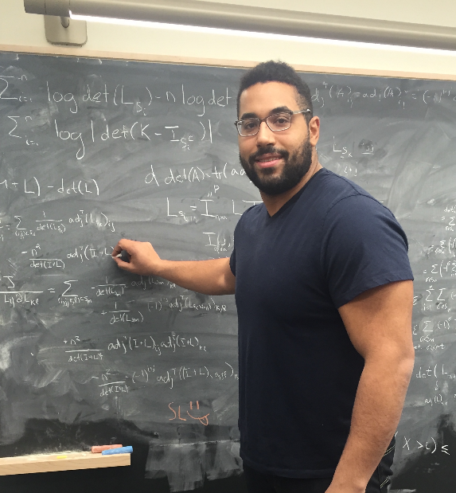

Iterative Methods for Matrices and Polynomial Optimization Problems
Wednesday, February 26, 2020
Mendel Hall, room 102
3:00 pm
(refreshments will be available)

The problem of solving a linear system $Ax=b$ or an eigenvalue problem $Ax = λx$, where $A$ is a very large, but sparse matrix, has become an increasingly important computational task, with applications in the solution of differential equations and the analysis of large data sets. The class of Krylov subspace methods has proven to be a powerful technique to address these problems and has led to well-known algorithms such as the conjugate gradient method, GMRES, Arnoldi iteration, and the Lanczos method. I will give a description of this class of methods and show the connection that the error analysis of these methods has to some polynomial optimization problems.

