Ph.D./Master’s Degree Candidates Only
College of Liberal Arts and Sciences

UNIVERSITY COMMENCEMENT CEREMONY, FRIDAY, MAY 18, 2018
(We encourage you to attend)
4:00 PM, Villanova Stadium (see page 2 for map of Stadium)
6:00 PM, President’s Reception
Click here for Schedule of Events
******************************************************************
GRADUATE STUDIES CONVOCATION, SATURDAY, MAY 19, 2018
TICKETS ARE NOT REQUIRED

Report to Villanova Stadium, Gate 3, no later than 1:00 PM
See Page 2 for Map of Stadium

- PLEASE REPORT TO VILLANOVA STADIUM (see page 2), Gate 3, walkway adjacent to Lancaster Avenue, NO LATER THAN 1:00 PM.
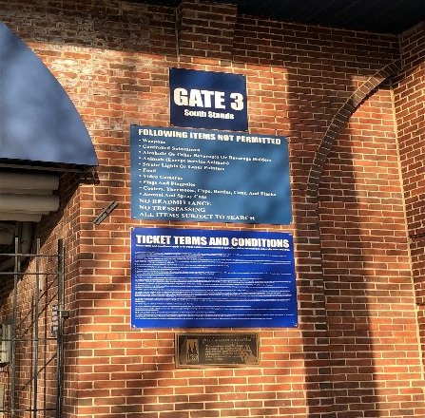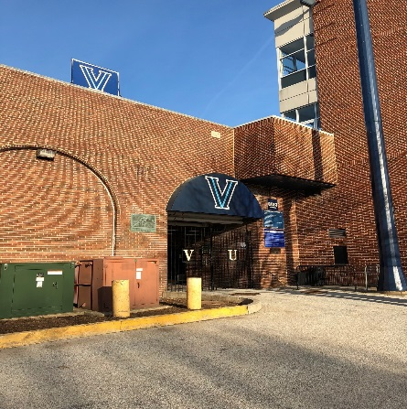

- Wear full academic regalia to the Graduate A&S Convocation Ceremony (Cap, tassel, hood, gown)

- Leave all extra items (purses, cell phones, etc.) with family before reporting to Villanova Stadium.

- Once you arrive, please pick up your information card that includes your name. You will see name card tables along the walkway adjacent to Lancaster Avenue. You will need to hand this card to the faculty member who is reading your name before you walk across the stage. Please do not lose the card!

- You will be asked to line up with your classmates outside of Gate 3, walkway adjacent to Lancaster Avenue, and will then process onto the field for the ceremony.

4:00 PM – Baccalaureate Mass, Campus Green
