Villanova Intramural Softball Home Run Derby Rules
- 30 minutes or 60 pitches per team
- Team pitches to themselves – every pitch counts!
- Field is designated into Zones corresponding to points (labeled on field diagrams below):

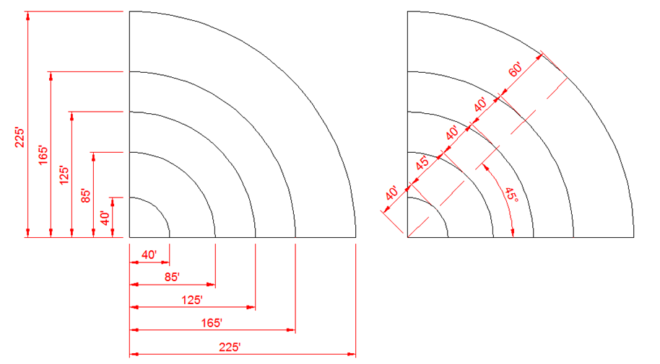
2

Home Run = 7
4
3
0
1
- Points are rewarded based on the zone in which the ball LANDS (not where it ends up!)
  - If a ball lands on a line, the higher point will be rewarded
- The blue boxes shown on the diagram above represent the location of umpires monitoring where each ball lands
- Each team receives 60 pitches OR 30 minutes
  - Batters will rotate in a batting order as they would in a regular softball game, with each batter receiving one pitch and rotating every pitch until the 60 pitches have been thrown or 30 minutes are up
  - All Men’s teams MUST meet the minimum requirement of having 8 batters present
  - All Coed teams MUST meet the minimum requirement of having 8 batters present, 4 being female and 4 being male. Batting order must rotate genders each batter.
- After your 60 pitches or 30 minutes are up, your score is tallied and will be updated on to a standings sheet displaying the point totals of every team. This sheet may be found on the Villanova Intramurals website.
- After all teams have had their first rounds, the TOP 8 MALE and TOP 8 COED teams will be brought back to participate in a championship round, during which the same rules will apply to each team. The team that has the highest point total from the championship round will be declared the champion of the 2014 IM Softball Home Run Derby!
- If there is a tie in total points after each team has participated in the championship round, each tied team will select one (1) batter to receive ten (10) pitches. Highest point total wins the ‘ship!

