Creating Permanent links to Chapters, Books, Transcripts and More
in Villanova Law Library’s PLI Plus Subscription
Note: links to PLI PLUS must be created using the following directions for the links to work from off-campus. Please contact your library liaison for further information.
1. Open the document or table of contents for the book you wish to link to on PLI PLUS
2. Click on the “Permalink” icon in the right corner of the document
3. A popup box will appear with a link to the document and will look like this:
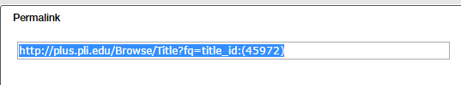
Highlight and Copy the text in this box and paste it into a word processing document. In this example, the copied text is:
http://plus.pli.edu/Browse/Titlefq=title_id:(45972)
4. Edit the pasted text as follows:
a. Insert the following at the front of the link: http://econtrol.law.villanova.edu:2048/login?url=
b. For example, the above permalink should now be:
http://econtrol.law.villanova.edu:2048/login?url=http://plus.pli.edu/Browse/Titlefq=title_id:(45972)
5. Copy and paste the new URL to Blackboard or insert in emails to send to Villanova Law students and faculty (they will be prompted to enter their Villanova user name and password once they click on the link)

